### Project Report on

# Project Title

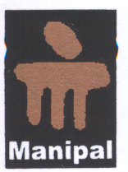

## By

**(Name of the student/s & RegNo/s)**

*In partial fulfillment of requirements for the award of degree in*

Bachelor of Technology in Computer Science and Engineering

(2016)



##### Under the Project Guidance of

**(Name of the Guide (with designation))**

## DEPARTMENT OF COMPUTER SCIENCE AND ENGINEERING

## SIKKIM MANIPAL INSTITUTE OF TECHNOLOGY

## (A constituent college of Sikkim Manipal University)

MAJITAR, RANGPO, EAST SIKKIM – 737136